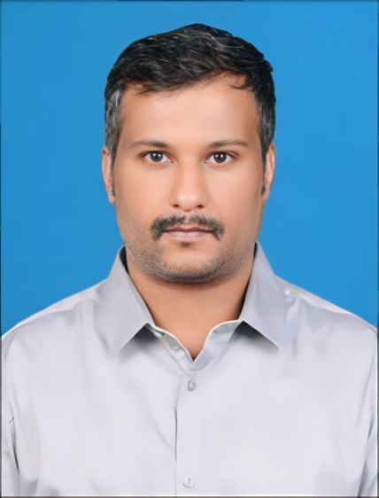

**Yuvaraj Rangaraj**

**Process Associate**

A result-driven professional with **6.5** years of experience in inventory, vendor management seeking for a position where I can utilize my skills and abilities to help myself and organization to achieve goals.

[](mailto:crvignesh95@gmail.com)

[1991yuvraj@gmail.com](mailto:1991yuvraj@gmail.com)

8903190390

Coimbatore, India

**Education**

* **MBA**

Bharathiyar University

2022

* **MA (English Literature)**

Govt. Arts college

Bharathiyar

University

2015

* **BA (English Literature)**

Kongunadu Arts & Science college

Bharathiyar

University

2013

**STRENGTHS**

* Disciplined and Focused
* Loyal & Trustworthy
* Collaborative Worker

# WORK EXPERIENCE

## Process Associate

### Vivek Flowers (American Firm)

*08/2021*

*Achievements/Tasks*

* Review customer’s documents.
* Analyzing the customer's legitimacy and providing approval for orders.
* Determining the product details for the clients via call
* Interacting with store supervisor and arranging staffs and to present the product to the customer.
* Arrange local products to acquire and sell in online.
* Requesting and responding to client feedback via mail and calls.
* Analyzing customers requirement for product improvements cycle
* Conducting market research and analysis to identify potential prospects, conduct outreach, and build customer relationships to drive sales.
* Analyzing data and generate reports to track and identify trends to make data-driven recommendations for improvement.
* Demonstrating products with sales data to prospective clients, negotiate contracts and close sales deals with stakeholders.
* Monitor customer feedback, reviews and ratings to identify areas of improvement and implement strategies for enhancing customer satisfaction and retention.
* Attend conferences, events, and trade shows to showcase our product and the retail sales team.
* Tracking Carrying out international cargo, domestic goods booking, monitoring FedEx on-time delivery tracking, negotiating cheaper rates with cargo companies, assigning the crew to cargo drop-offs in line with flight schedules, and accounting cargo bills.

## F & B Banquet Manager

### Gem Park

### 05/2016-07/2021

*Achievements/Tasks*

* Overseeing the daily operation of hotel ensuring efficient management and providing strategic direction.
* Supervising staffs, assigning tasks and boosting employee’s morale.
* Vendor management ensuring accuracy and timeliness
* Involved in verifying and reconciling invoice and payment
* Collaborated with other departments and team members to gather financial information and resolving issues and support business objectives.

# SOFTWARE SKILLS

**MS Offic**

**MS excel**

**LANGUAGES**

*Full Professional Proficiency*

* English
* Tamil
* Kannada

# WORK EXPERIENCE

* Interacting with service users and others in a way that preserves self-esteem and a good image
* Maintaining a healthy and safe practice, and attending meetings as scheduled.
* Ensuring guest satisfaction by offering welcoming surroundings and personalized replies to feedback from customers.

## Declaration:

## I hereby declare that all information and facts given above are true to the best of my knowledge and belief.

## Yours truly,

## Yuvaraj.